Lab 4: Persistence, Autoscaling & Rolling Updates
Closing the Durability Gap, Scaling Under Load, and Shipping Safely

What You Will Do
This lab closes three remaining gaps in the stack built across Labs 1 through 3. First, PostgreSQL is given persistent storage that survives Pod restarts -- the gap deliberately left open in Lab 1. Second, the API is connected to a Horizontal Pod Autoscaler and put under real load to watch it scale up and back down. Third, a new version of the API is rolled out with zero downtime, then deliberately rolled back, to prove deployments are safe to ship and safe to undo.

Learning Objectives
- Understand PersistentVolumes and PersistentVolumeClaims, and prove data survives a Pod deletion
- Install and patch metrics-server, the component HPA depends on for real usage data
- Create a HorizontalPodAutoscaler and observe a full scale-up and scale-down cycle under generated load
- Understand why resource requests are mandatory for HPA to function at all
- Perform a rolling update and a rollback, and read Deployment revision history

Prerequisites
- Labs 1-3 completed: postgres, api, and frontend Pods all Running
- Ingress working: http://localhost/ loads the Angular app and successfully calls /api/db-check

Part A — Persistent Storage for PostgreSQL
In Lab 1, deleting a Pod proved Kubernetes' self-healing behavior -- but it also proved something uncomfortable: the replacement Pod got a completely empty filesystem. Any data PostgreSQL had written was gone. This part closes that gap before moving on to anything else, since a production database without durable storage is not a usable database.

Step A1 — Understand the two objects involved
PersistentVolume (PV) vs PersistentVolumeClaim (PVC)
A PersistentVolume is a piece of real storage in the cluster -- a chunk of disk space, independent of any particular Pod's lifecycle.
A PersistentVolumeClaim is a request for storage made by a Pod -- "I need 1Gi of space." Kubernetes matches claims to available volumes.
This separation means storage survives even if the Pod requesting it is deleted and recreated. The new Pod's claim binds to the same existing volume, not a new, empty one.

Step A2 — Create the PersistentVolumeClaim
On Docker Desktop, a default StorageClass automatically provisions the underlying volume for you, so only a PVC needs to be defined explicitly.
04-postgres-pvc.yaml
apiVersion: v1
kind: PersistentVolumeClaim
metadata:
name: postgres-pvc
spec:
accessModes:
- ReadWriteOnce
resources:
requests:
storage: 1Gi
ReadWriteOnce means the volume can be mounted as read-write by a single node at a time -- the correct mode for a single-instance database like this one.

Step A3 — Update the PostgreSQL Deployment to use it
Two additions to the existing Deployment from Lab 2: a volumeMounts entry inside the container, and a volumes entry at the Pod spec level referencing the PVC.
04-postgres-with-storage.yaml
apiVersion: apps/v1
kind: Deployment
metadata:
name: postgres
labels:
app: postgres
spec:
replicas: 1
selector:
matchLabels:
app: postgres
template:
metadata:
labels:
app: postgres
spec:
containers:
- name: postgres
image: postgres:16
ports:
- containerPort: 5432
env:
- name: POSTGRES_DB
value: appdb
- name: POSTGRES_USER
value: appuser
- name: POSTGRES_PASSWORD
valueFrom:
secretKeyRef:
name: postgres-secret
key: DB_PASSWORD
- name: PGDATA
value: /var/lib/postgresql/data/pgdata
volumeMounts:
- name: postgres-storage
mountPath: /var/lib/postgresql/data
volumes:
- name: postgres-storage
persistentVolumeClaim:
claimName: postgres-pvc
---
apiVersion: v1
kind: Service
metadata:
name: postgres
spec:
selector:
app: postgres
ports:
- port: 5432
targetPort: 5432
Why the PGDATA environment variable is added
Postgres' own data directory and the volume mount point both default to /var/lib/postgresql/data. Mounting a fresh volume directly there can conflict with a hidden lost+found directory some storage drivers create. Pointing PGDATA at a subfolder (pgdata) inside the mount avoids that conflict entirely.

Step A4 — Apply the updated storage configuration
kubectl apply -f 04-postgres-pvc.yaml
kubectl apply -f 04-postgres-with-storage.yaml
kubectl get pvc
kubectl get pods --watch
Confirm the PVC shows STATUS Bound, and the postgres pod restarts and reaches 1/1 Running again.
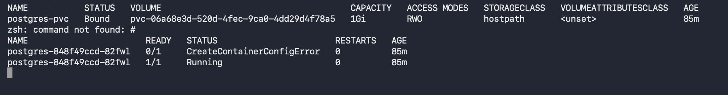

Step A5 — Prove data survives a Pod deletion
- Open a shell into the postgres pod and connect with psql.
- Create a table and insert one row.
- Exit, then delete the postgres pod directly.
- Wait for the replacement pod to reach Running.
- Connect again and confirm the table and row still exist.
kubectl exec -it postgres-848f49ccd-82fwl -- psql -U appuser -d appdb

-- inside psql:
CREATE TABLE proof (id SERIAL PRIMARY KEY, note TEXT);
INSERT INTO proof (note) VALUES ('data survived a pod restart');
\q
kubectl delete pod postgres-848f49ccd-82fwl
kubectl get pods --watch
Once the new pod is Running, reconnect and check:
kubectl exec -it postgres-848f49ccd-m5ftr -- psql -U appuser -d appdb -c "SELECT * FROM proof;"
The row should still be there. Compare this directly to Lab 1, where deleting the unmounted Postgres pod lost everything -- the only difference now is the PersistentVolumeClaim.
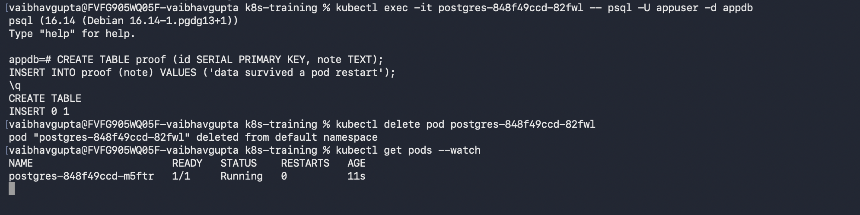
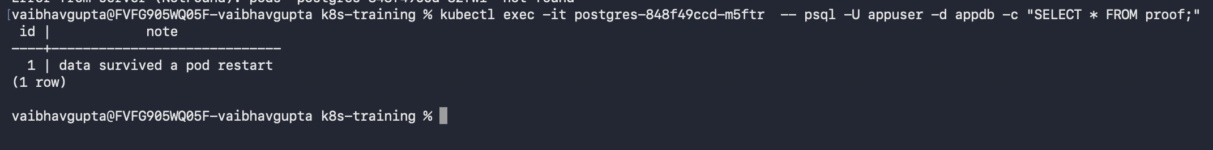

Part B — Autoscaling Under Load

Step B1 — Why resource requests are mandatory for this to work at all
The HorizontalPodAutoscaler's entire logic is a percentage: "this pod is using X% of what it requested." Without a CPU request defined on the container, there is no denominator for that percentage, and HPA cannot make a scaling decision. This is the single most common reason HPA appears not to work in real clusters -- the request was simply never set. The api Deployment from Lab 2 already defines:
resources:
requests:
cpu: "100m"
limits:
cpu: "500m"
This is what makes everything in this section possible.

Step B2 — Install metrics-server
HPA does not measure CPU or memory itself -- it asks a separate component, metrics-server, for that data. Docker Desktop does not install this by default.
kubectl apply -f https://github.com/kubernetes-sigs/metrics-server/releases/latest/download/components.yaml
kubectl get pods -n kube-system
Look for a pod named metrics-server-... Note its READY column -- 0/1 at this stage is expected and addressed in the next step.

Step B3 — Patch metrics-server for local clusters
Why this step is needed
metrics-server tries to verify the node's TLS certificate strictly by default. Local clusters with self-signed certificates fail this check, which shows up as the pod staying at 0/1 Ready, and a log entry similar to: x509: cannot validate certificate ... because it doesn't contain any IP SANs. This is a routine, expected step for any local kind or Docker Desktop cluster -- not something to do on a real production cluster with properly issued certificates.
Confirm the cause first:
kubectl logs -n kube-system deployment/metrics-server
Then patch the deployment to skip strict TLS verification. On Windows cmd.exe, the quoting must use escaped double quotes, not single quotes, around the JSON patch:
kubectl patch deployment metrics-server -n kube-system --type=json -p="[{\"op\":\"add\",\"path\":\"/spec/template/spec/containers/0/args/-\",\"value\":\"--kubelet-insecure-tls\"}]"
If the quoting still causes errors in your shell, use the interactive editor instead, which avoids the issue entirely:
kubectl edit deployment metrics-server -n kube-system
# add this line under the existing args: list, then save and close:
# - --kubelet-insecure-tls
kubectl get pods -n kube-system --watch
Wait for the new metrics-server pod to reach 1/1 Running, then confirm it is genuinely serving data:
kubectl top pods
kubectl top nodes
Real CPU and memory numbers, not an error, confirm metrics-server is fully functional and HPA now has something to read.
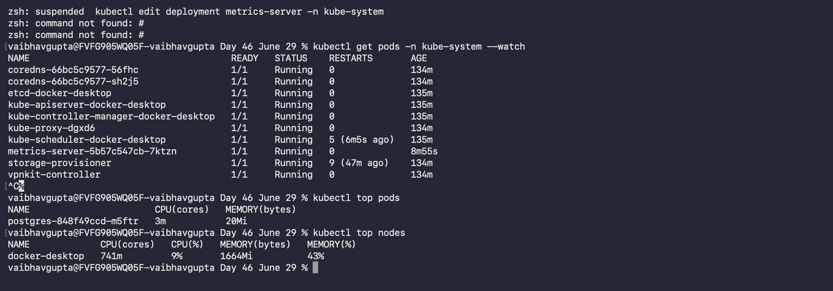

Step B4 — Create the HorizontalPodAutoscaler
04-api-hpa.yaml
apiVersion: autoscaling/v2
kind: HorizontalPodAutoscaler
metadata:
name: api-hpa
spec:
scaleTargetRef:
apiVersion: apps/v1
kind: Deployment
name: api
minReplicas: 1
maxReplicas: 5
metrics:
- type: Resource
resource:
name: cpu
target:
type: Utilization
averageUtilization: 50
scaleTargetRef points this HPA at the api Deployment specifically. minReplicas and maxReplicas set the floor and ceiling it will never cross. averageUtilization: 50 means: keep average CPU usage across all pods at roughly 50% of what each pod requested (50% of the 100m request set in Lab 2 is 50m) -- sustained movement past that threshold triggers scaling in either direction.
kubectl apply -f 04-api-hpa.yaml
kubectl get hpa
At idle, expect a reading close to 1%/50%, with REPLICAS at 1 -- no load yet, so nothing to react to.
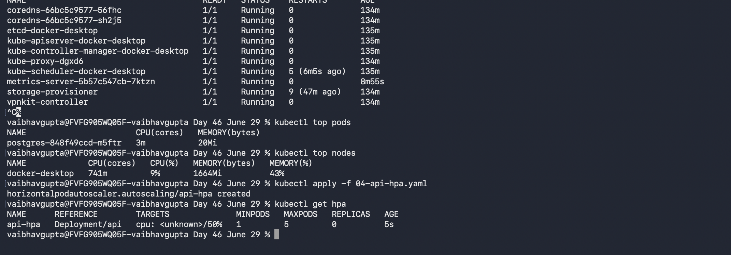

Step B5 — Generate real load and watch it scale up
Run a disposable pod inside the cluster that hammers the API continuously:
kubectl run load-generator --image=busybox --restart=Never -- /bin/sh -c "while true; do wget -q -O- http://api:8080/ ; done"
In a separate terminal, watch the HPA react live:
kubectl get hpa --watch
Give it one to two minutes -- HPA polls periodically and wants sustained load, not a single spike, before acting. Watch TARGETS climb past 50% and REPLICAS increase as a result, up to the maxReplicas ceiling of 5.
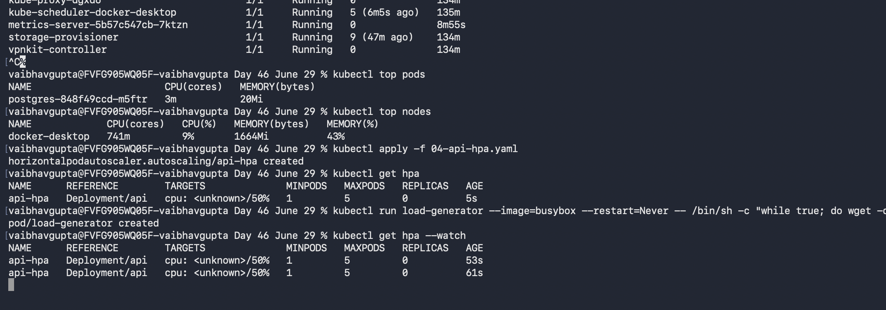

Step B6 — Remove the load and watch it scale back down
kubectl delete pod load-generator
kubectl get hpa --watch
Why scaling down takes longer than expected
HPA applies a scale-down stabilization window (5 minutes by default), and within that window it does not simply wait -- it keeps a rolling history of recent recommendations and always applies the highest one seen in that window, not the most current reading. Run kubectl describe hpa api-hpa and check the Conditions section: a ScaleDownStabilized reason with a message like "recent recommendations were higher than current one" confirms this is expected behavior, timed from the most recent scale-up event, not from when load actually stopped.
Keep watching for a few minutes. REPLICAS should step back down toward 1 once the stabilization window from the last scale-up event has fully elapsed.
kubectl describe hpa api-hpa
Check the Events section at the bottom for SuccessfulRescale entries, and the Conditions section for AbleToScale and its current Reason -- this is the authoritative source for what HPA is doing and why, at any moment.
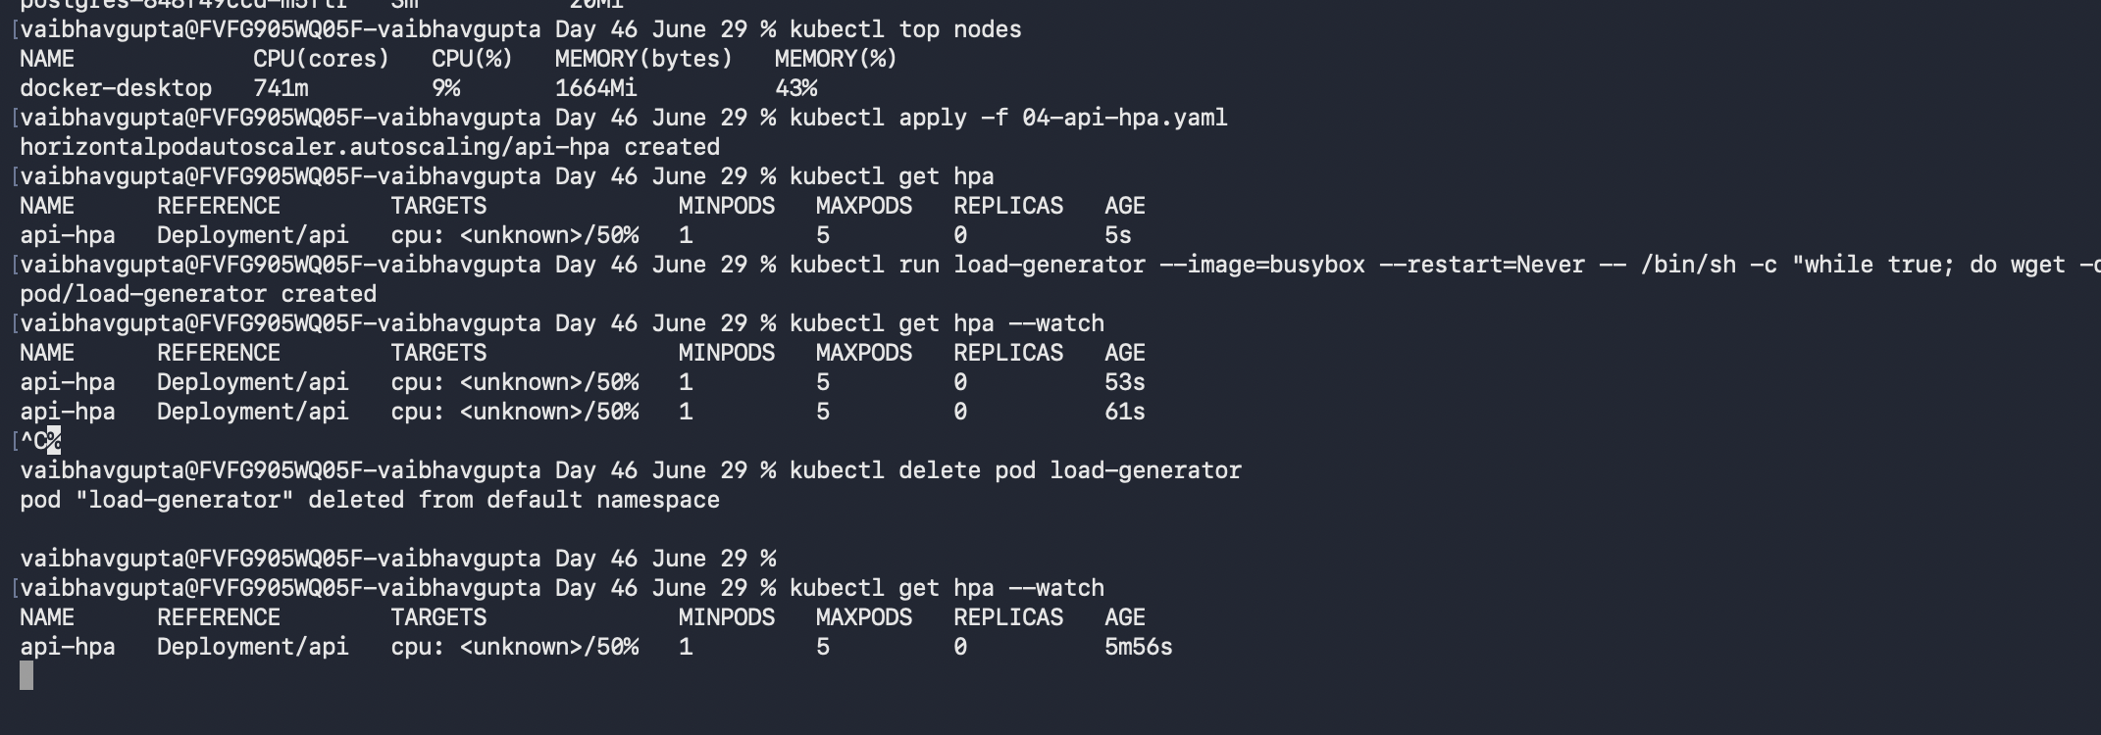
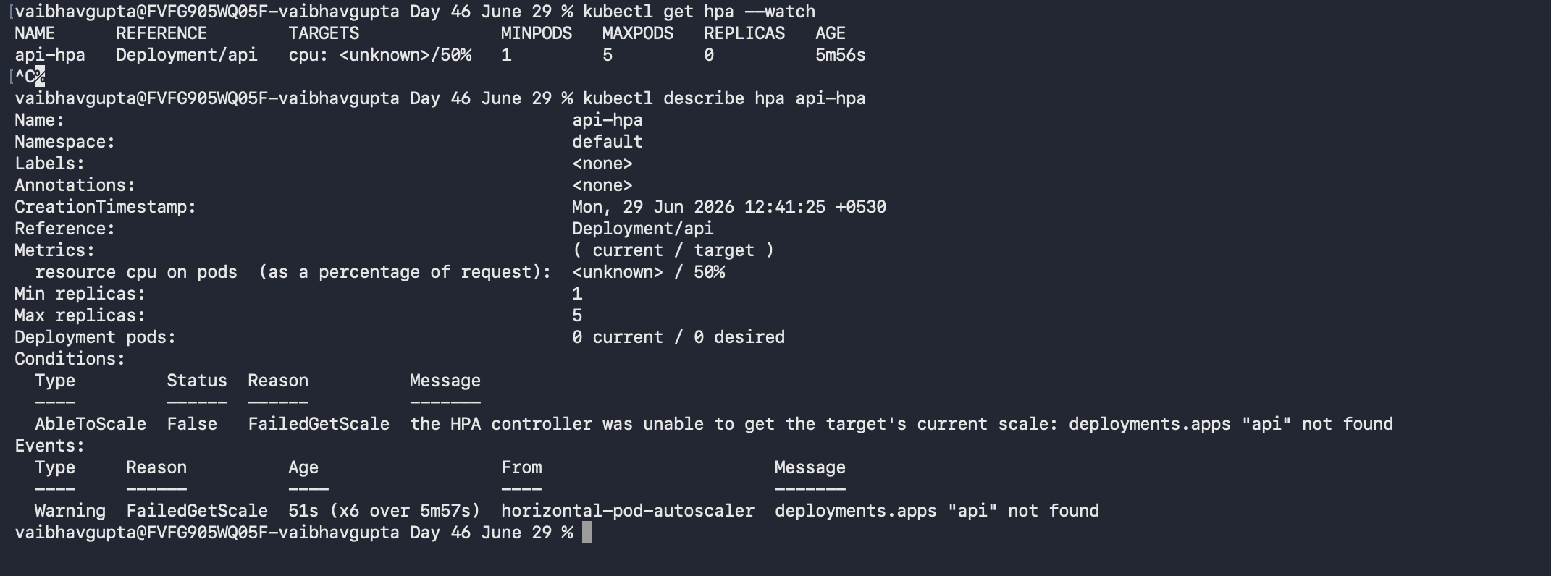

Part C — Rolling Updates & Rollback
A Deployment manages not just how many replicas exist, but which version they are running, gradually swapping old pods for new ones rather than killing everything at once. This part ships a small, visible change to the API and proves it can be shipped safely, and undone safely.

Step C1 — Make a visible change
In Program.cs, change the version reported by the root endpoint:
// Before:
return Results.Ok(new { message = "API is running", version = "1.0" });

// After:
return Results.Ok(new { message = "API is running", version = "2.0" });

Step C2 — Build and load the new version under a distinct tag
Always tag versions distinctly, never reuse :latest for this
Using a separate, meaningful tag per build (v2 here, not latest) is what makes rollback possible later. If every build shares the same tag, Kubernetes has no way to distinguish which version a given revision actually ran, and there is nothing concrete to roll back to.
docker build -t myapi:v2 .
docker save myapi:v2 | docker exec -i desktop-control-plane ctr -n=k8s.io images import -
(Substitute your actual kind node container name if different from desktop-control-plane.)

Step C3 — Trigger the rolling update
kubectl set image deployment/api api=myapi:v2
kubectl rollout status deployment/api
kubectl get pods --watch
Watch closely: a new pod running myapi:v2 starts, becomes Ready (passing its readinessProbe), and only then does the old pod terminate. This overlap, however brief, is the entire point of a rolling update -- the old version keeps serving traffic until the new version has proven itself ready, so there is no window where zero pods are available.
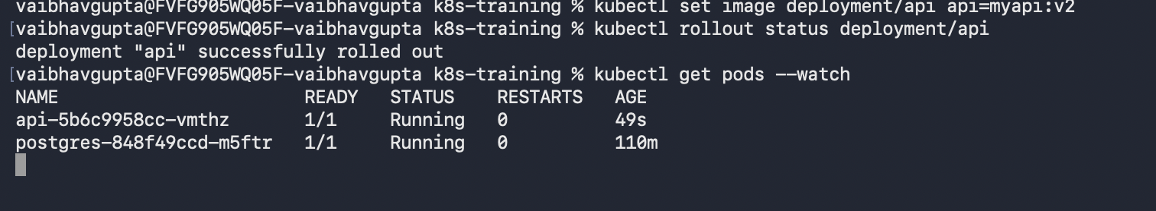

Step C4 — Confirm via revision history
kubectl rollout history deployment/api
Why CHANGE-CAUSE often shows <none>
Kubernetes always tracks revisions automatically and reliably -- this column is purely cosmetic. It only gets populated if a change-cause annotation or the (now deprecated in newer kubectl versions) --record flag was used at the time of the change. An empty CHANGE-CAUSE does not mean history was lost; it means the human-readable reason was never recorded. The per-revision template is still available in full regardless.
To see exactly what changed in any revision, view its full pod template directly:
kubectl rollout history deployment/api --revision=<number>
Confirm the most recent revision shows Image: myapi:v2.
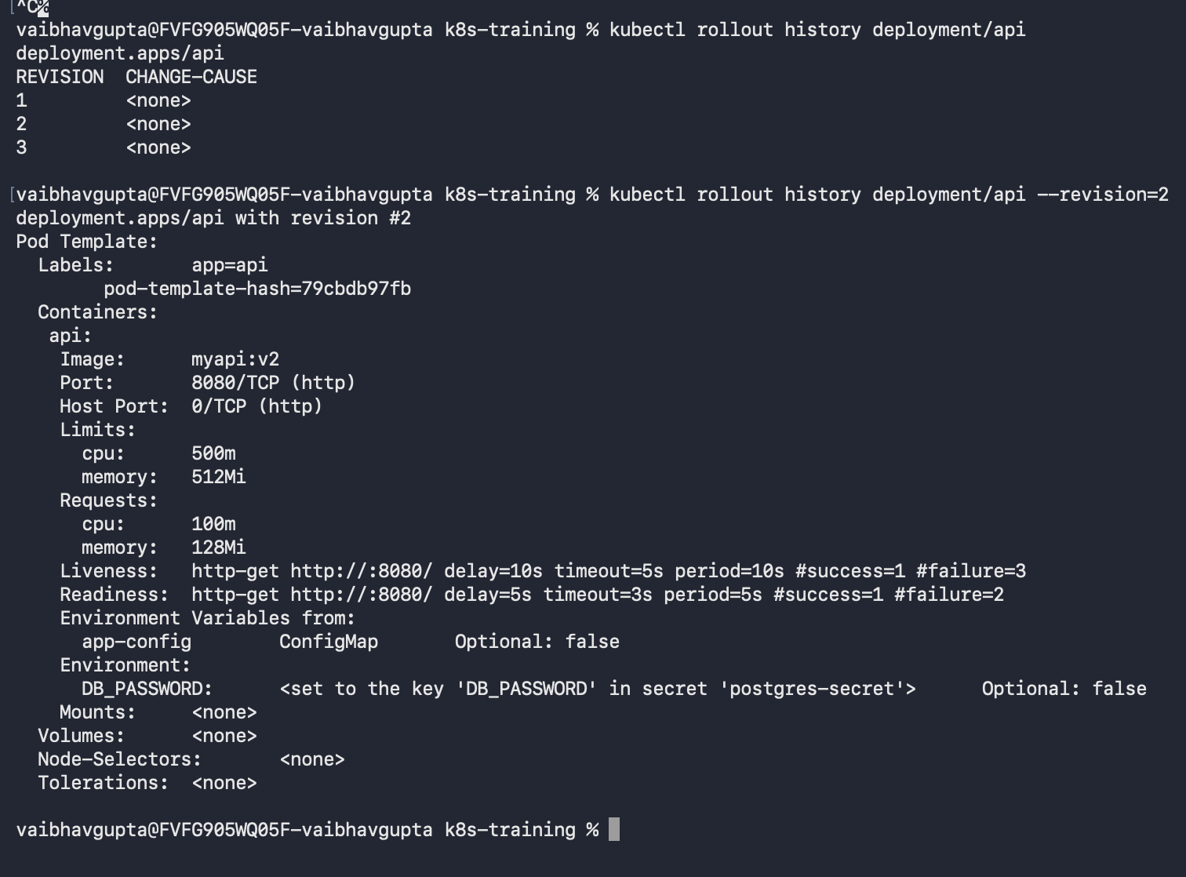

Step C5 — Roll back
Suppose v2 turned out to be broken. Reverting requires no YAML editing at all:
kubectl rollout undo deployment/api
kubectl rollout status deployment/api
Confirm the image reverted to the previous version:
kubectl get deployment api -o jsonpath="{.spec.template.spec.containers[0].image}"
This single command reverted a live deployment to its previous known-good state. The same rolling mechanism applies in reverse -- the old (now "new again") version is brought up and proven Ready before the broken version is removed.
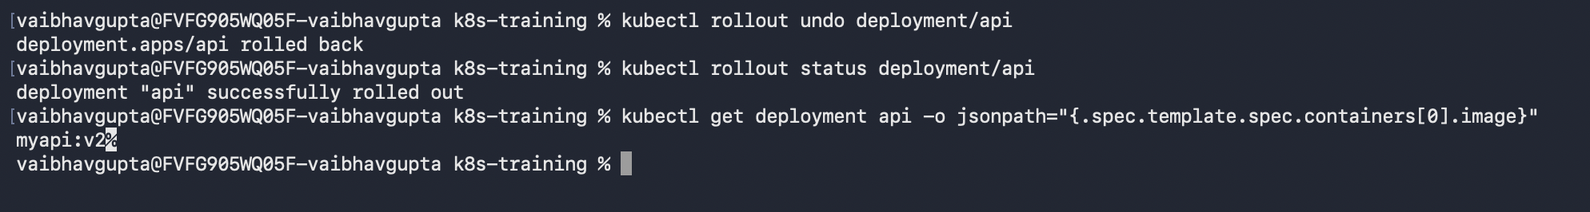

Troubleshooting Reference
Symptom | Likely Cause / Fix
PVC stuck in Pending | No StorageClass available to satisfy the claim. Confirm with kubectl get storageclass that a default class exists.
Postgres pod fails to start after adding the volume | Check kubectl logs <pod-name> for a permissions or lost+found error; confirm PGDATA points to a subfolder, not the mount root.
kubectl top pods returns an error, not numbers | metrics-server is not Ready yet, or the --kubelet-insecure-tls patch was not applied or has not taken effect. Re-check kubectl get pods -n kube-system.
HPA TARGETS shows <unknown>/50% | Same root cause as above -- HPA cannot read metrics-server data yet. Resolve that first; HPA itself is not broken.
HPA never scales up despite load-generator running | Confirm the api Deployment actually defines resources.requests.cpu. Without it, HPA has no baseline percentage to calculate against.
Replicas stay high long after load-generator is deleted | Expected. Check kubectl describe hpa api-hpa for a ScaleDownStabilized condition -- the 5-minute window is timed from the last scale-up event, and applies the highest recent recommendation, not the current reading.
kubectl patch with --type=json fails on Windows with a quoting error | cmd.exe does not strip single quotes the way bash does. Use escaped double quotes as shown in Step B3, or use kubectl edit instead.
New pod never becomes Ready during a rollout, old pod never terminates | The new image is likely failing its readinessProbe. Check kubectl logs on the new pod and kubectl describe pod for probe failure details.

Key takeaway
Every mechanism in this lab depends on the same underlying idea from Lab 1: Kubernetes continuously reconciles declared state against actual state. A PersistentVolumeClaim declares storage should persist regardless of which Pod is attached to it. An HPA declares a target utilization and lets the control loop add or remove replicas to match it. A rolling update declares a new Pod template and lets the control loop replace old Pods with new ones, never all at once. Nothing here is a new mechanism -- it is the same reconciliation loop from Hour 1, applied to storage, to scale, and to version.

